

Travlr Getaways Full Stack Web Application

CS 465 Project Software Design Document
Version 1.2

Table of Contents

CS 465 Project Software Design Document 1
Table of Contents 2
Document Revision History 2
Instructions 2
Executive Summary 3
Design Constraints 3
System Architecture View 3
Component Diagram 3
Sequence Diagram 4
Class Diagram 4
API Endpoints 4
The User Interface 4

Document Revision History

Version | Date | Author | Comments
1.0 | 1/25/2026 | Jeremy Brown | Completed the Executive Summary, Design Constraints, and Component Diagram
1.1 | 2/5/2026 | Jeremy Brown | Completed Sequence Diagram and Class Diagram
1.2 | 2/20/2026 | Jeremy Brown | Completed the User Interface

Executive Summary

The Travlr Getaways web application will be developed using the MEAN stack, which consists of MongoDB, Express.js, Angular, and Node.js. Node.js will serve as the application runtime, providing the foundation on which the entire system operates. The application will be divided into two main components: a customer facing site that presents travel content and an administrative interface used to manage that content.
The customer facing portion of the application will utilize Express.js, Handlebars, and MongoDB. Express.js will act as the web framework responsible for serving the site’s pages and handling requests. Handlebars will be used as the templating engine to dynamically populate static pages with content retrieved from the database. MongoDB, a NoSQL database, will store the travel data and page content that Handlebars injects into the templates before they are delivered to users.
The administrative side of the application will be implemented as a single page application using Angular. This interface will allow administrators to securely authenticate and log in before accessing management features. Once authenticated, administrators will be able to create, update, and remove content displayed on the customer facing site. All administrative actions will directly modify the corresponding documents stored in MongoDB, ensuring that changes made in the admin portal are immediately reflected across the application.

Design Constraints

Several design constraints must be considered when developing the Travlr Getaways web application using the MEAN technology stack. One primary constraint is the need to update content on the static portion of the website without requiring a full redeployment of the application. This requires a design that separates content management from application deployment so that changes made by administrators can be reflected immediately.
The application must also be responsive to ensure a consistent and user-friendly experience across a variety of devices, including desktops, tablets, and mobile phones. This constraint influences layout design, navigation structure, and component scaling to accommodate different screen sizes and interaction methods.
Another key constraint is the requirement that the administrative portal be implemented as a single page application (SPA). The SPA architecture must dynamically load and display administrative components, allowing administrators to manage site content efficiently without unnecessary page reloads. This places additional emphasis on client-side routing, state management, and secure authentication mechanisms.
There are also constraints related to the individual components of the MEAN stack. MongoDB, while well suited for web applications due to its flexibility and scalability, may experience performance degradation as data volume grows if indexing and data modeling are not carefully managed. Additionally, while Express.js, Angular, and Node.js integrate effectively to form the MEAN stack, their combined use can result in a large and complex codebase that may be challenging to maintain over time without consistent structure and documentation.
Finally, adopting the MEAN stack introduces a migration constraint. If an existing traditional website is converted to the MEAN architecture, reverting back to a non-MEAN solution can be difficult due to the tightly coupled nature of the stack and the reliance on JavaScript across both the client and server sides of the application.

System Architecture View

Component Diagram

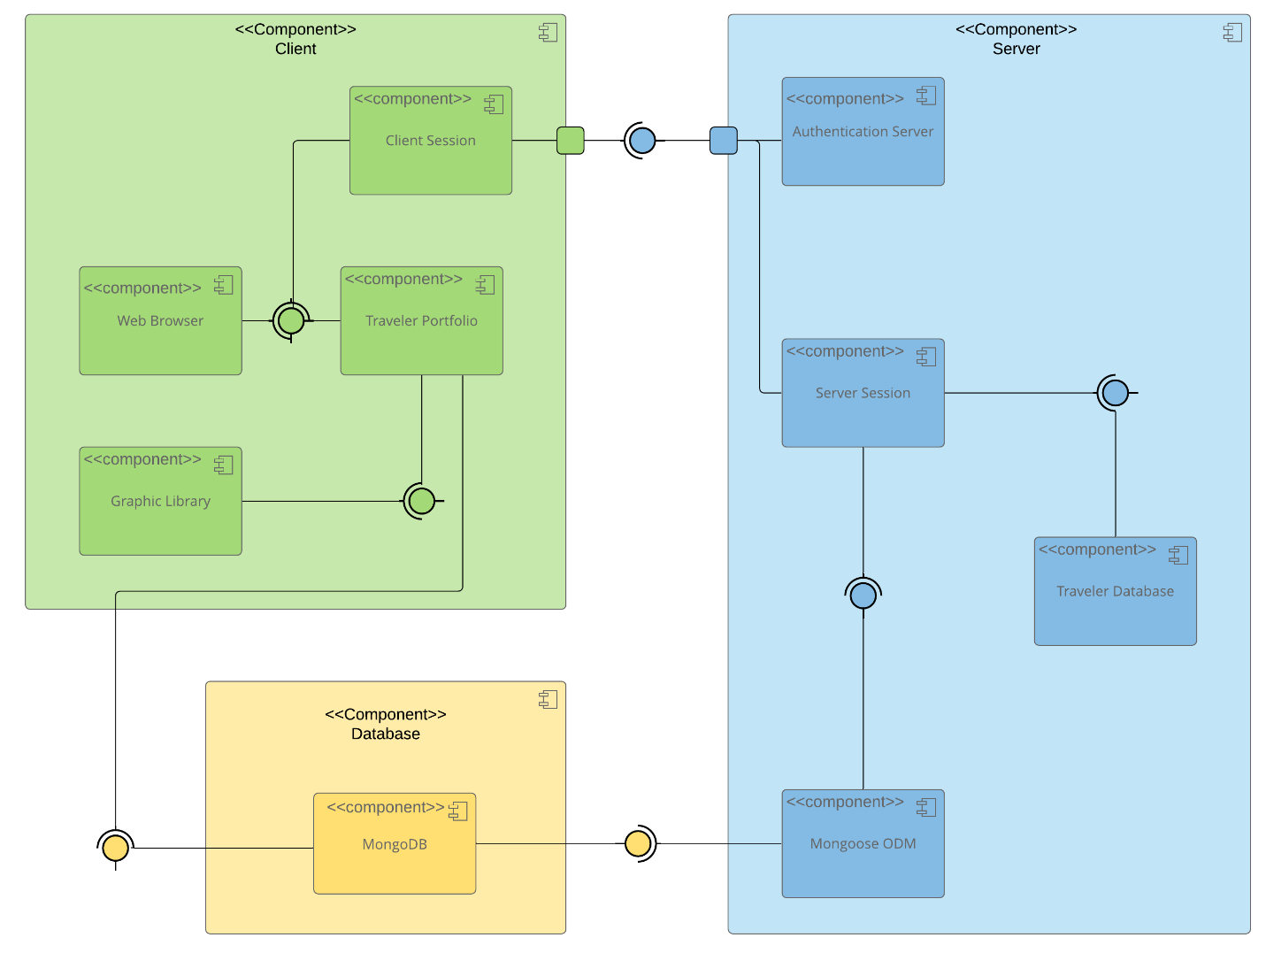
The Travlr Getaways web application is designed using a three tier architecture consisting of the client tier, application tier, and data tier. This layered approach separates presentation, application logic, and data management, improving scalability, maintainability, and security. The component diagram illustrates how these tiers interact through defined interfaces to support both user facing functionality and administrative operations.
The client tier includes the Web Browser, Client Session, Traveler Portfolio, and Graphic Library components. The web browser serves as the primary user interface and communicates with the traveler portfolio to display travel related content. The traveler portfolio relies on the graphic library to render visual elements and enhance the user experience. The client session component manages user state on the client side and acts as the communication point between the client and server tiers, particularly for authentication and session related requests.
The application tier contains the Authentication Server, Server Session, Traveler Database, and Mongoose ODM components. The authentication server is responsible for validating user credentials and establishing secure access to protected features. Once authenticated, the server session maintains the user’s session state and coordinates requests between the client tier and backend services. The server session interacts with the traveler database component to retrieve and manage application data. All database operations are handled through the Mongoose ODM, which provides schema enforcement and structured access to the data layer.
The data tier consists of the MongoDB component, which stores traveler information and site content. MongoDB is accessed exclusively through the Mongoose ODM in the application tier, preventing direct client access and ensuring consistent data validation and security.
Together, these tiers and components work through required interfaces to support secure authentication, efficient data access, and dynamic content delivery across the Travlr Getaways web application.

Sequence Diagram

The sequence diagram begins with the user as the actor. The user enters a route, which is handled by the frontend router and directs them to the appropriate view or template. That view then calls its related controller, which fills in the needed data, renders the template, and returns the view to be displayed to the user. The frontend controller requests data by calling functions in the HTTP service, and the results of those calls are sent back to the controller. The HTTP service acts as the connection between the frontend and backend by making API requests to specific backend routes. On the backend, the router receives the request and determines which backend controller should handle it. The backend controller then queries the database using Mongoose. After receiving the data, the controller sends the results back through the HTTP service to the frontend. Finally, the MongoDB database processes the query and returns the requested data.

Class Diagram

The CruiseInfo, FlightInfo, and HotelInfo classes each include a name attribute along with additional fields that are specific to their respective types of travel. All three of these classes inherit from the TripInfo class, which defines shared properties such as start and return dates and origin and destination locations. The CruiseBooking, FlightBooking, and HotelBooking classes are associated with their corresponding Info classes as well as the TravellerInfo class. There is a zero-to-many relationship in both directions between the Booking classes and the TravelAgent class. The TravelAgent class is also associated with the CruiseInfo, FlightInfo, HotelInfo, and TravellerInfo classes, and it has a one-to-many relationship with the MembershipAdmin class. The TravellerInfo class inherits from the MemberAccount class, while the MembershipAdmin class has an aggregation relationship with the MemberAccount class. Finally, the Itinerary class aggregates the CruiseInfo, FlightInfo, and HotelInfo classes.

API Endpoints

Method | Purpose | URL | Notes
POST | Login a user | /api/login | Authenticates a user and returns a JWT
POST | Register a user | /api/register | Adds a new user to the database and returns a JWT
GET | Retrieve list of meals | /api/meals | Returns all meals
GET | Retrieve single meal | /api/meals/:mealCode | Returns a single meal identified by the meal code at the end of the URL
GET | Retrieve list of news | /api/news | Returns all news content
GET | Retrieve single piece of news content | /api/news/:newsCode | Returns a single news item identified by the news code at the end of the URL
GET | Retrieve list of rooms | /api/rooms | Returns all rooms
GET | Retrieve single room | /api/rooms/:roomCode | Returns a single room identified by the room code at the end of the URL
GET | Retrieve list of trips | /api/trips | Returns all trips
POST | Add a trip | /api/trips | Adds a new trip to the database
GET | Retrieve single trip | /api/trips/:tripCode | Returns a single trip identified by the trip code at the end of the URL
PUT | Update single trip | /api/trips/:tripCode | Updates a single trip identified by the trip code at the end of the URL
DELETE | Delete single trip | /api/trips/:tripCode | Deletes a single trip identified by the trip code at the end of the URL

The User Interface
The below screenshots show a trip I created, the trip being edited, and the updated trip.

Angular is a frontend framework where views are rendered on the client side, while Express is a backend framework where views are rendered on the server and then sent to the client. The Angular project is structured around models, services, routes, and reusable components that work together inside a single page application. Instead of loading new pages from the server, Angular dynamically updates content within one main HTML file. Express, on the other hand, follows an MVC structure with routes, controllers, and views, using a templating engine like Handlebars to generate HTML on the server before delivering it to the browser. Both applications rely on APIs to send and retrieve data, but Angular handles user interaction and page updates in the browser, while Express focuses on server side logic and database communication.
SPAs provide several advantages, including reduced server load after the initial page load, faster user interactions without full page refreshes, and a more interactive experience through client side routing. However, they can have a longer initial load time and may require additional effort for SEO optimization. To test that the SPA works correctly with the API, I used the admin interface to verify functionality. Loading the trip list confirmed that the GET request successfully retrieved data from the database. Editing and saving a trip verified that the PUT request updated the database correctly when the changes appeared in the list view. During testing, I encountered a 404 error when I forgot to start the Express backend, which highlighted that the SPA depends entirely on the API being active in order to communicate with the database.

